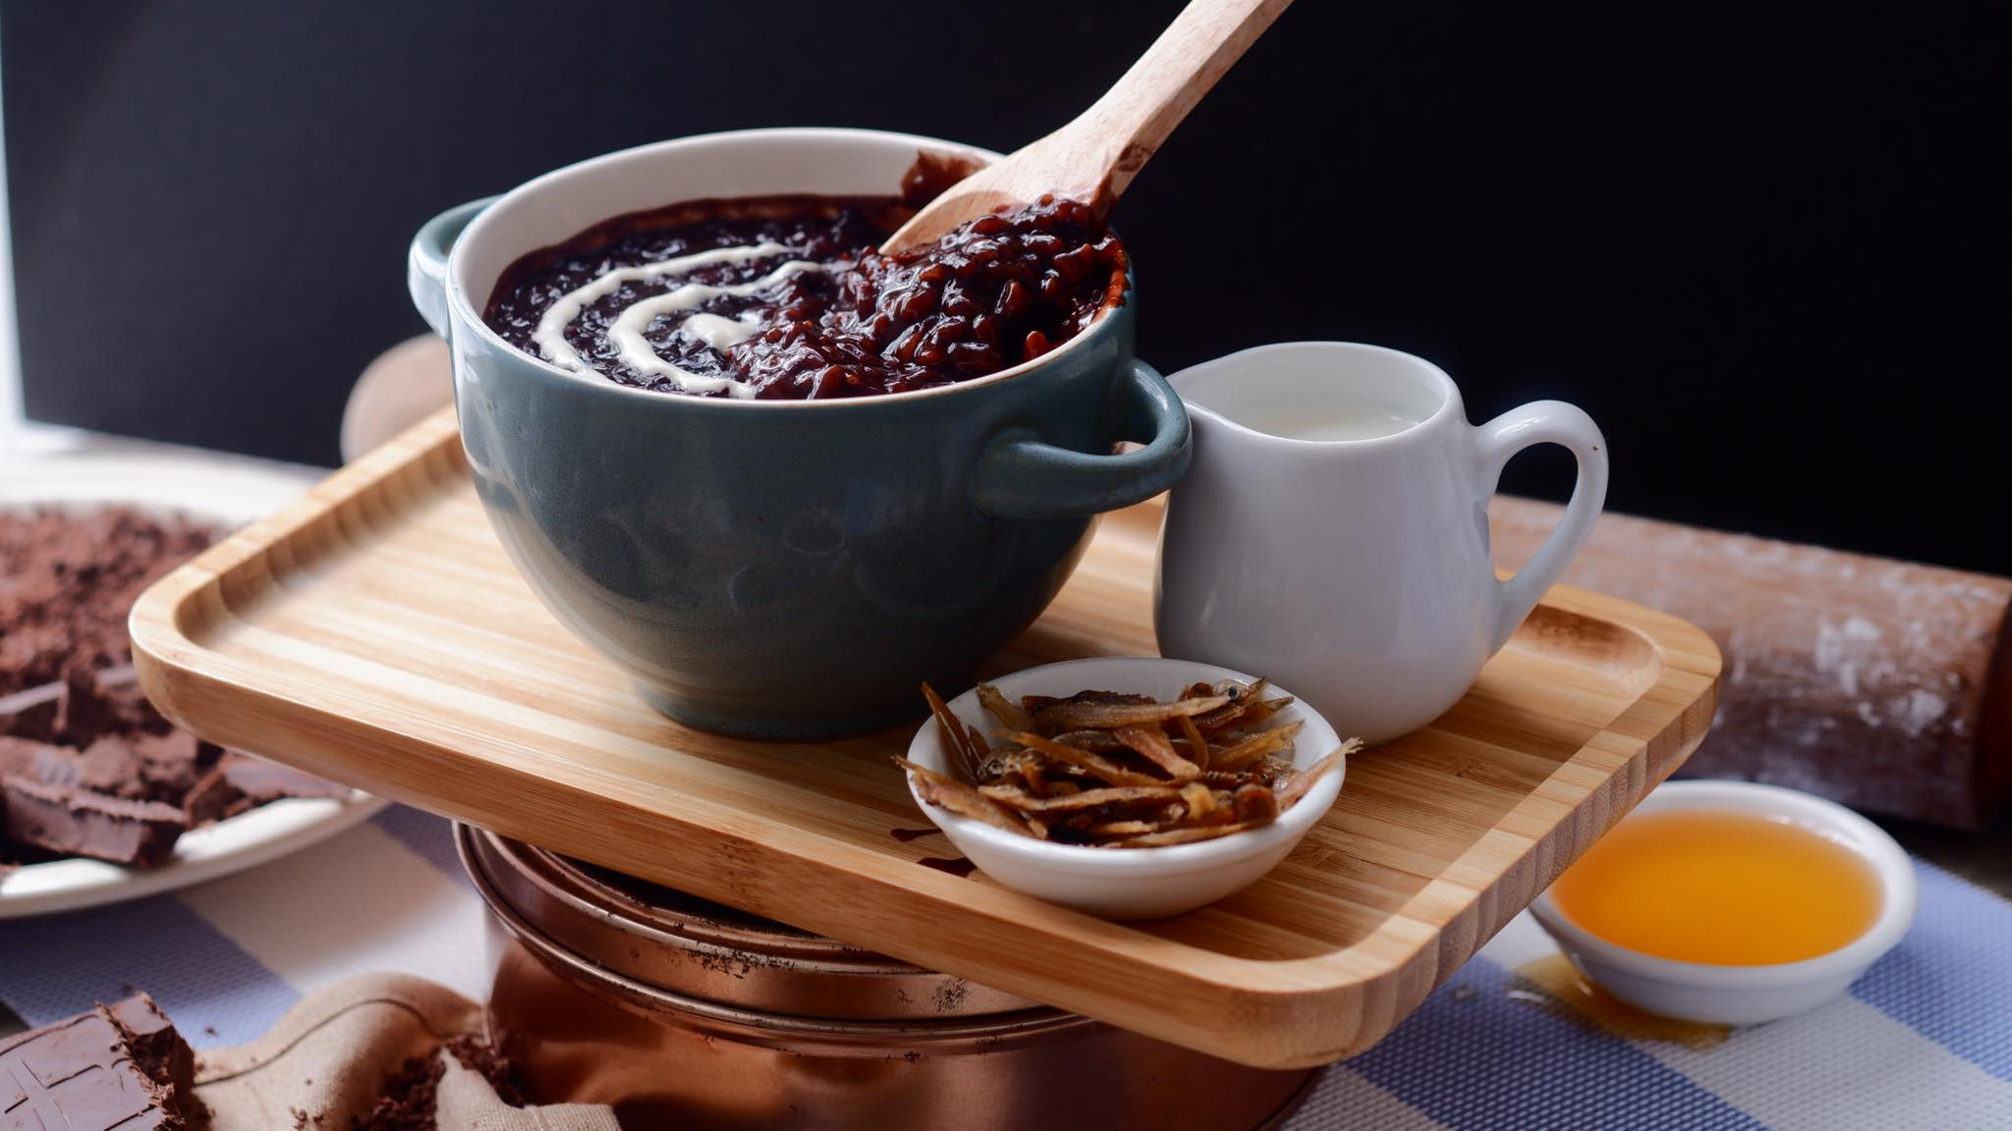

**DARK CHOCOLATE CHAMPORADO 90.00**

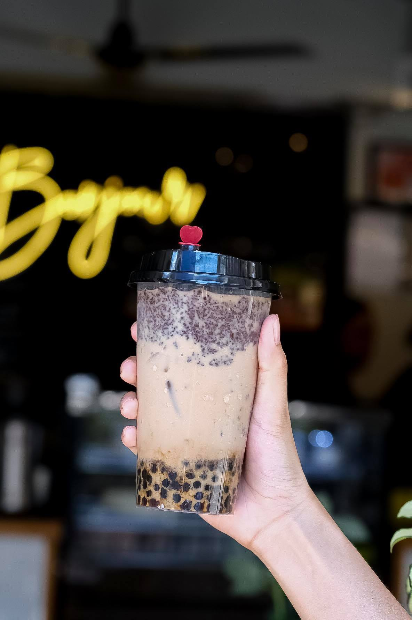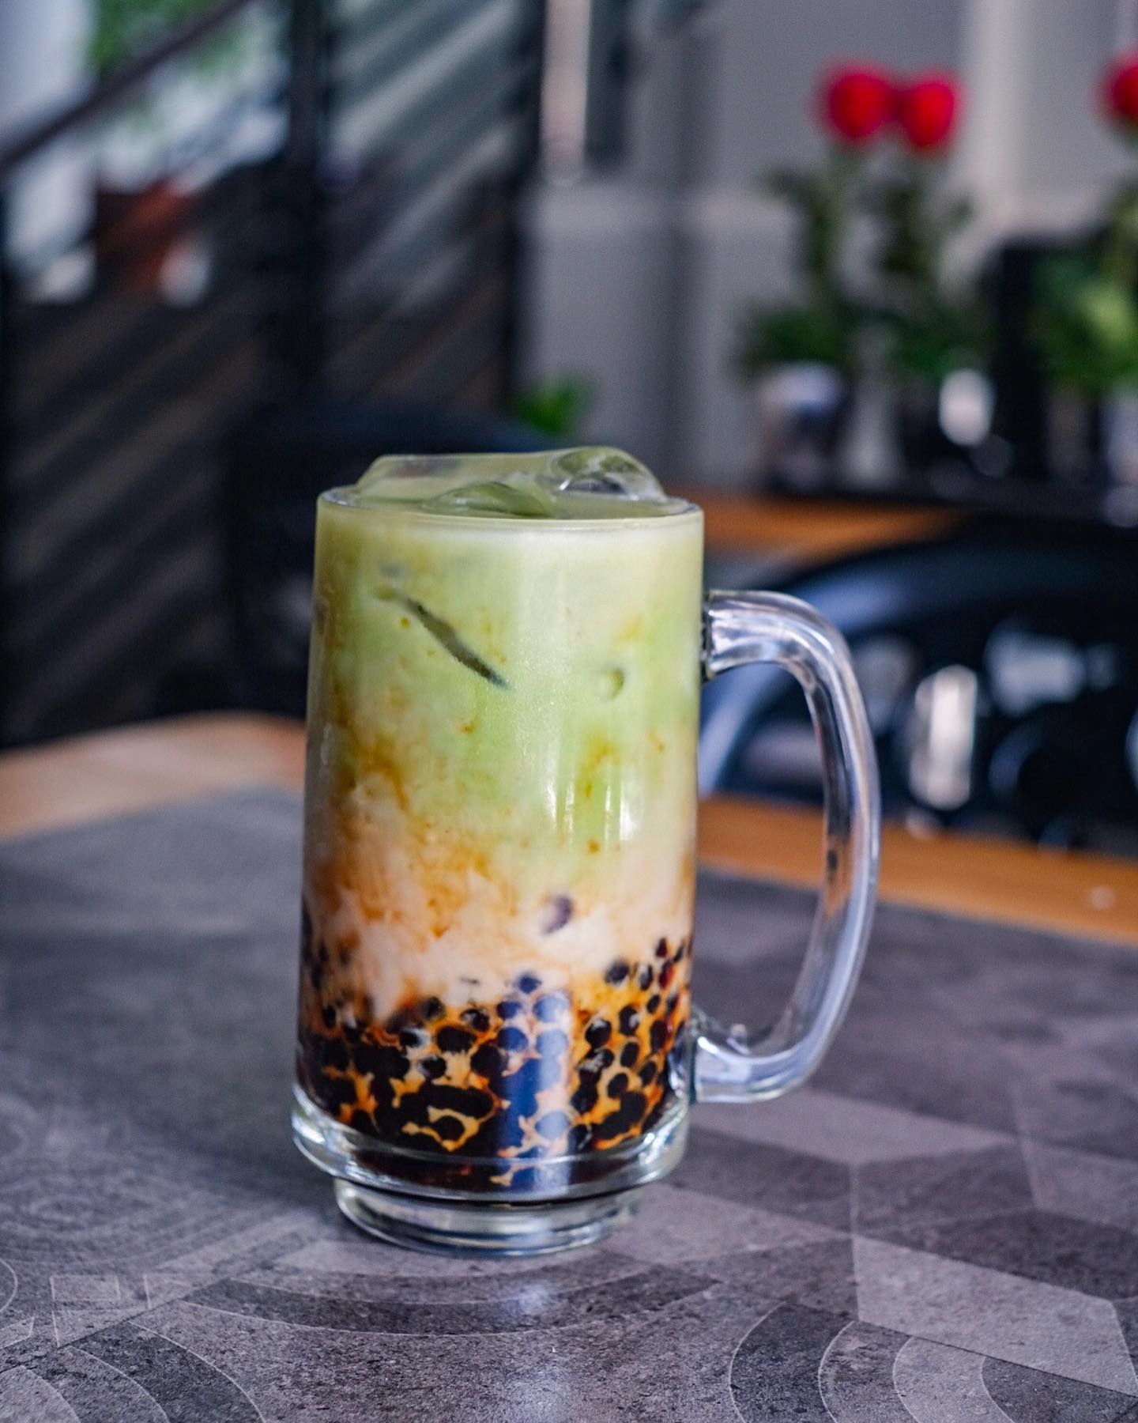

**MATCHA-OKINAWA 95.00 OREO-OKINAWA 95.00**